**Topics: Loop, Range, List, String, Dictionary**

**Marks: 4 + 4 + 2 (submission)**

**Duration: 40 (Start: 2:10, End: 2:50, Submission: 2:55)**

1. Sum the following series using for loop:
   1. 1 + 4 + 9 + 16 + ….. + Up to **n-th** term= ? (Hint: square series) [4]
2. You have a group of 3 students. Each student has a name, ID and dept stored in a dictionary. And all 3 students are stored in a “students” dictionary. Now use a loop to iterate through the “students” dictionary and print only the “name” of all the students.

**OR**

You have a **list** of students. Each student’s information is stored using a dictionary.

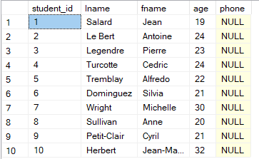

Now write a python program to search a student by his/her ID. Use a loop and conditional (or only conditional) so that this can also work on a big list of students.

**Coding test guidelines:**

**1. Open a new file in google colab**

**2. Rename: A1_CT_3_ID**

**3. Share the file with me (**[**tsr@uap-bd.edu**](https://mail.google.com/mail/?view=cm&fs=1&to=tsr%40uap-bd.edu&authuser=0)**)**

**4. After solving the problems submit the file in google classroom from google drive (Choose the file with "CO" logo).**

**\*\* Connect your webcam during the test**